create table Hostels (

hostel_id INT PRIMARY KEY,

hostel_name VARCHAR(30) UNIQUE,

location VARCHAR(50) NOT NULL,

total_rooms INT NOT NULL CHECK (total_rooms IS NOT NULL),

warden_name VARCHAR(40)

)

insert into Hostels values(101,'alpha','main',50,'roja')

insert into Hostels values(102,'magnus','kharadi',10,'pinky')

insert into Hostels values(103,'puri','nimapara',20,'neha')

insert into Hostels values(104,'greeland','pipil',30,'dezy')

select * from Hostels;

create table Rooms (

Room_id INT PRIMARY KEY,

floor INT NOT NULL,

capacity INT NOT NULL CHECK(CAPACITY>0),

status NVARCHAR(30) CHECK(status='occupied' or status='vacant' or status='under maintenance') DEFAULT 'vacant',

hostel_id INT,FOREIGN KEY (hostel_id) REFERENCES Hostels(hostel_id) ON DELETE CASCADE

)

insert into Rooms values(301,1,2,'vacant',101)

insert into Rooms values(302,2,4,'vacant',102)

insert into Rooms values(303,3,1,'vacant',103)

insert into Rooms values(304,4,3,'vacant',104)

select * from Rooms;

create table Students (

Student_id INT PRIMARY KEY,

Student_name varchar(100) NOT NULL,

Date_of_Birth DATE NOT NULL,

Gender varchar(10) NOT NULL,

Contactnumber varchar(20) UNIQUE NOT NULL,

Email varchar(100) UNIQUE NOT NULL,

Address TEXT NOT NULL,

JoiningDate DATE NOT NULL,

Status VARCHAR(20) DEFAULT 'active',

Room_id INT,FOREIGN KEY (Room_id) REFERENCES Rooms(Room_id) ON DELETE CASCADE

)

insert into Students values(1,'Maya Singh','1998-07-21','Female','1234567891','maya123@gmail.com','123 main city','2024-07-03','active',301)

insert into Students values(2,'Ashis Kumar','1999-05-24','Male','1234567892','ashu@gmail.com','45 grandroad','2024-03-04','active',302)

insert into Students values(3,'Shriya Kumari','2002-06-30','Male','1234567893','shriya@gmail.com','63 guhalapada','2024-02-05','active',303)

insert into Students values(4,'Sunil Kumar','2022-09-13','Female','1234567894','rishi@gmail.com','51 paikpada','2024-07-06','active',304)

select * from Students;

CREATE TABLE Staff (

staff_id INT PRIMARY KEY,

staff_name NVARCHAR(58) NOT NULL,

role NVARCHAR(50) NOT NULL,

contact_number NVARCHAR(20) UNIQUE,

Email NVARCHAR(100) UNIQUE,

hostel_id INT,FOREIGN KEY (hostel_id) REFERENCES Hostels(hostel_id) ON DELETE CASCADE

)

insert into Staff values(1,'Ruby Dey','maintenance','1122345','ruby@gmail.com',101)

insert into Staff values(2,'Sonali Sahoo','warden','2332678','sonali@gmail.com',102)

insert into Staff values(3,'Subhasmita Dash','maintenance','33256689','subhasmita@gmail.com',103)

insert into Staff values(4,'Anjali Pattnaik','warden','33221175','anjali@gmail.com',104)

select * from Staff;

CREATE TABLE Facilities (

facility_id INT PRIMARY KEY,

facility_name NVARCHAR(50) NOT NULL,

hostel_id INT,FOREIGN KEY (hostel_id) REFERENCES Hostels(hostel_id) ON DELETE CASCADE

)

insert into Facilities values(1,'Study room',101)

insert into Facilities values(2,'Educom class',102)

insert into Facilities values(3,'Live class',103)

insert into Facilities values(4,'Kitchen',104)

select * from Facilities;

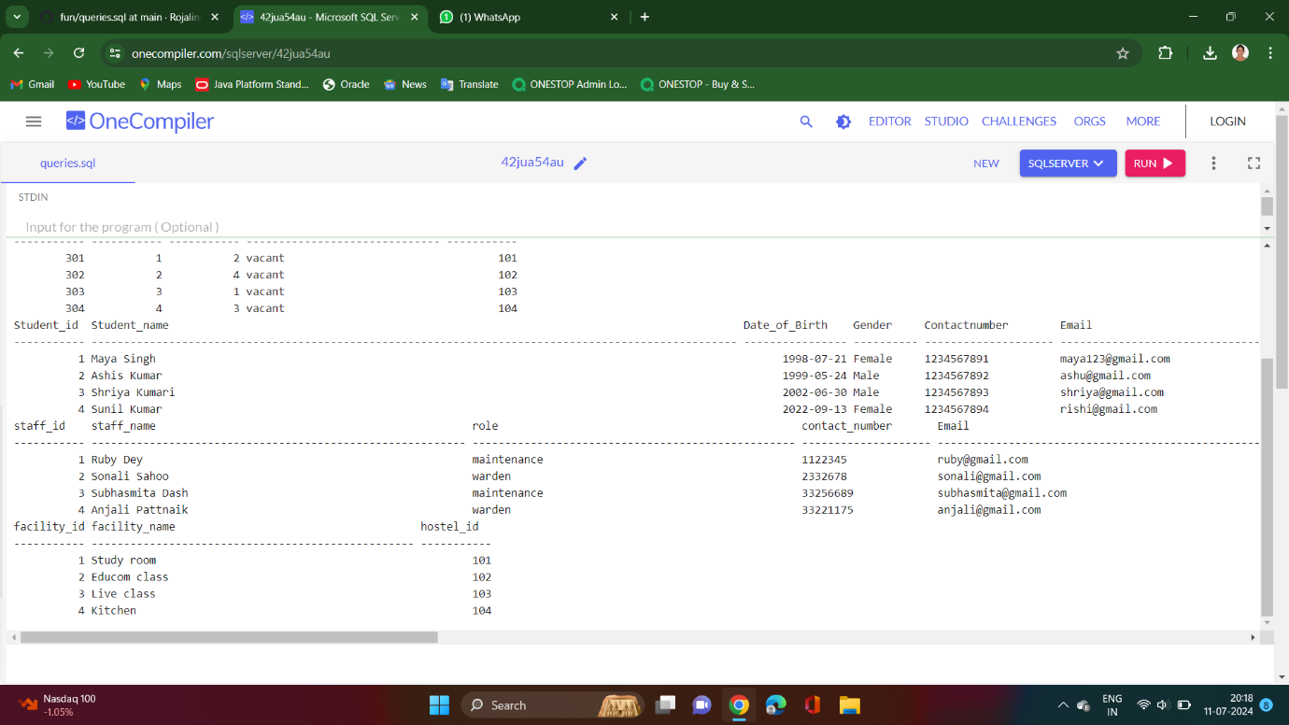

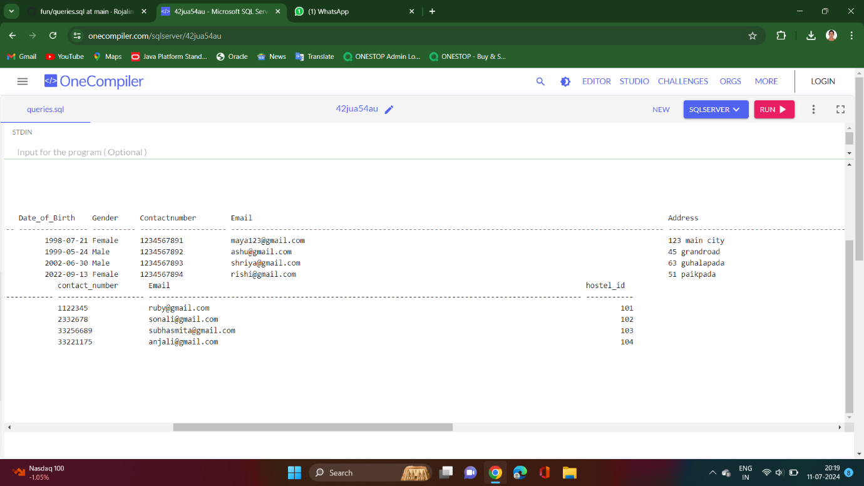

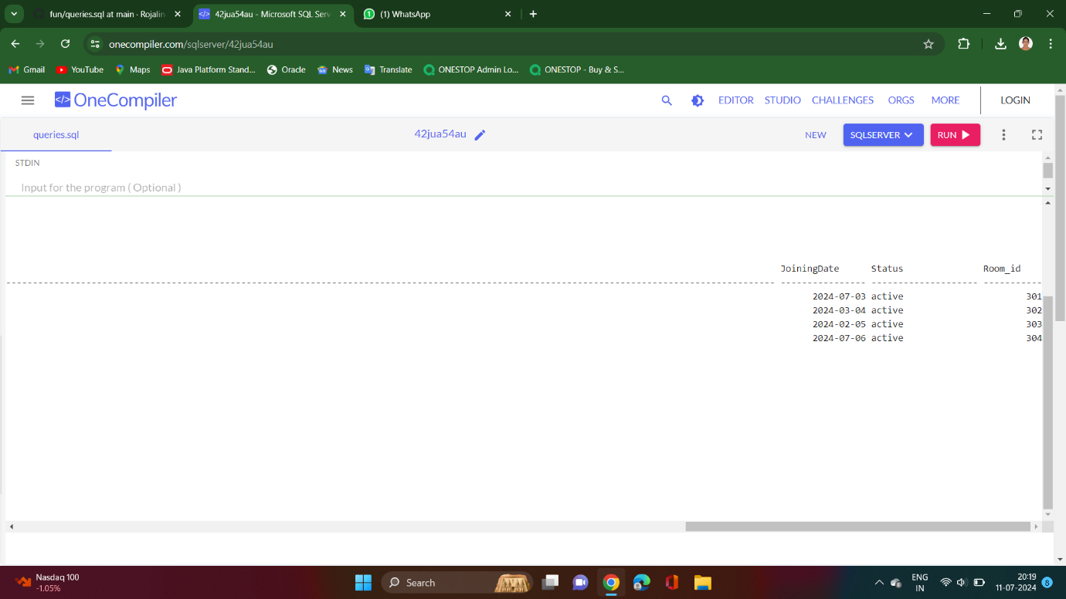s